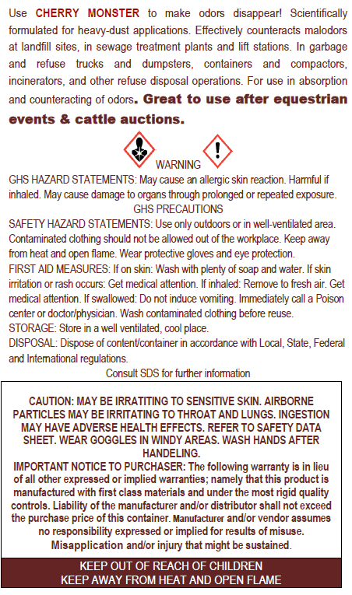 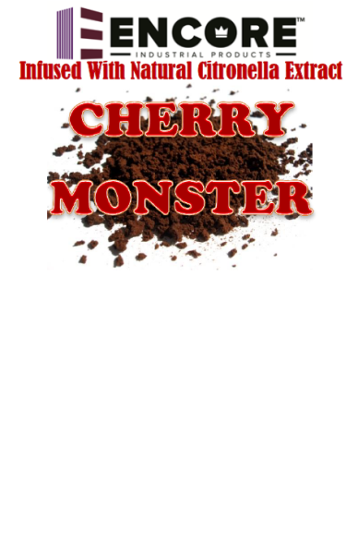 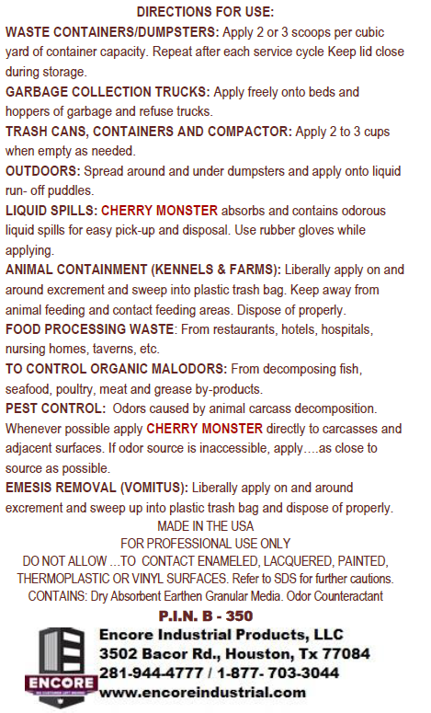

**Suppresses Gaseous Malodors in**

**Waste Management**

**Sewage Operations and Lift Stations**

**Destroys Trash and Garbage Odors**

**Ideal for dumpsters and Compactors**

**Biodegradable & V.O.C. Compliant**

**Instantly Neutralizes Malodors**

**Absorbs Odor-Causing Spills**

**Easy to Apply & Repels Insects**

**Provides Long- Lasting Odor Control**

**Excellent for Use on Cruise Liners and Sailing Vessels, Garbage Trucks, and Drying Beds**

**USDA APPROVED**

Net Contents: 2 LBS

**GRANULATED ODOR COUNTERACTANT**

**For Municipal, Institutional, and Restaurant Waste**