|  |
| --- |
| **Directions for Use** |

**For Grease Tubes** – Follow directions on grease gun for loading instructions. To insure proper service pump out any existing grease prior to applying or pumping **Encore Industrial’s Litho Tek EP.**

**For Pails & Drums –** Follow directions indicated on the grease pump for proper use.

|  |
| --- |
| HMIS Codes |
| Health 0 |
| Flammability 1 |
| Reactivity 0 |
| Personal Protection B |

P.I.N - G – 170

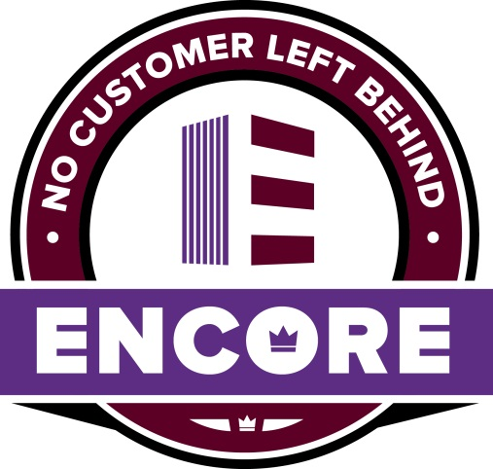



**LITHO TEK EP**

**LITHIUM BASED EXTREME PRESSURE GREASE**

NLGI – 2

TimKen Ok Load – 65 LBS

High Temp - 400⁰

Low Temp - 0⁰

4 – Ball weld point – 250 kgf

Neutral in color

|  |
| --- |
| **Keep Out of Reach of Children** |

Net Contents: 35LB

Encore Industrial Products, LLC

PO Box 300

Barker, TX  77413-0300

281-944-4777 or 1-877-703-3044

**Litho Tek** sets the standard for durability & stability under adverse conditions. This industrial grease protects against damaging ware and heat stress. This unique formula is fortified with an EP extreme pressure package for high pressure service applications. Superior rust and oxidation stabilizers help extend equipment service life.

|  |
| --- |
| **First Aid Information** |

Read MSDS for complete information

**Eye Contact** – Flush eyes with clean water for at least 15 minutes. If irritation occurs call a physician.

**Skin contact** – Wash skin with soap and water, if irritation occurs, call a physician.

**Ingestion** – Do not induce vomiting and give large quantities of water. Call a physician immediately if stomach pains or nausea occur.

To reorder call:

1-877-703-3044 or 281-944-4777

