|  |
| --- |
| **Directions for Use** |

1. PRP is used for repairing potholes and utility cuts in highways, roads, streets, parking areas, and driveways. PRP adheres to steel and is used for repairs around manholes and drainage grates.

2. PRP is ready for use from the pail. No mixing or tack coat is required as. Pour directly from the pail into the pothole.

3. PRP can be used at all times of the year and in all weather conditions.

4. PRP displaces water and may be poured directly into potholes containing standing water.

5. Small loose aggregate can be left in place. Large loose aggregate should be removed.

6. Use PRP instead of hot mix asphalt for repairs of utility cuts and cable trenches for longer lasting repairs.

7. Allow traffic to immediately drive over a repaired pothole – the more traffic, the faster the setup time.

8. Clean tools with soy based cleansers or with solvents like kerosene and mineral spirits (paint thinner).

9. Do not apply heat to PRP or use kerosene, mineral spirits (paint thinner), or any other solvents in the application and use of PRP.

10. Areas patched with PRP can be resurfaced like any other pavement.



**PRP**

**Pothole Repair Patch**

**Superior cold patch**

**Contains proprietary plastics**

**No tack coat required**

**More durable than hot mix**

**Performs like a large expansion joint**

**Temperature range 0 to above 100 degrees**

**Weight: 60 lbs.**

|  |
| --- |
| **Keep Out of Reach of Children** |

**Encore Industrial Products, LLC**

**PO Box 300, Barker, TX 77413**

**281-944-4777 or 1-877-703-3044**

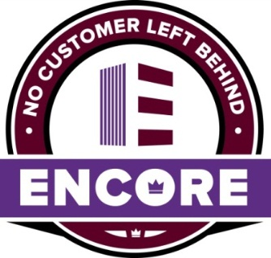

**To reorder call:**

**1-877-703-3044 or 281-944-4777**

**Warranty**

Encore Industrial Products, LLC warrants our product to be free of manufacturing defects. Liability for product proven defective, if any, is limited to replacement of defective product or refund of the purchase price paid for the defective product as determined by Encore Industrial Products, LLC. No other warranty or guarantee of any kind is made by Encore Industrial Products, LLC expressed or implied, statutory, by operations or law or otherwise including merchantability and fitness for a particular purpose.

**www.encoreindustrial.com**