ENCORE INDUSTRIAL SUPREME HYDRAULIC OIL AW-32

Ideal for industrial applications. Provides trouble free performance in high pressure high output industrial configurations. Helps eliminate sludge build up caused by heat. Designed to separate from water quickly to safeguard against etching acids or corrosives.

P.I.N. G-210

Health | 1
Flammability | 1
Reactivity | 0
Personal | B

Batch Number: #325150977

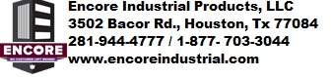

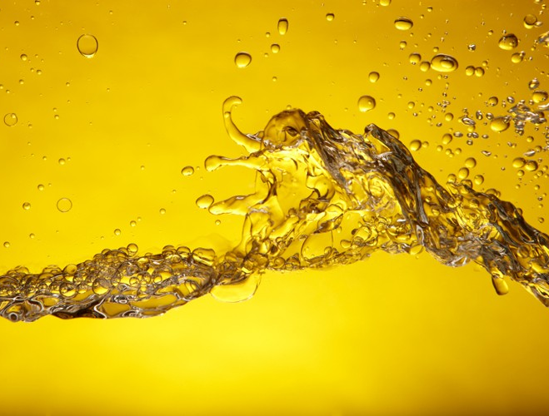
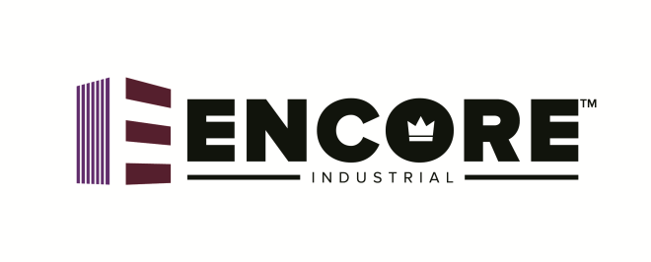
SUPREME HYDRAULIC OIL
AW-32
For Onshore & Offshore Use
Low Foaming Formulation with Minimal Oxidation
Inhibits Rust & Corrosion
Enhanced with Anti-Wear Additives
Typical Characteristics
Flash Point ⁰F | 420
Pour Point ⁰F | -20
ISO VG Number | 32
Pounds Per Gallon | 7.21
Gravity (API) | 31.6
Viscosity (cST @ 40⁰) | 28.5-35.2
Viscosity SUS @ 100⁰F | 155

Caution
Keep Out Of Reach of Children
Net Contents 220 Gallons

First Aid
Inhalation: Vapors generated at high temperatures (only) or oil mist may cause mild irritation of the nose, throat and respiratory system. Consult physician and poison control immediately.
Eye Irritation: May cause minimum eye irritation. Consult physician and poison control immediately.
Skin Contact: May cause minimum skin irritations, long term heavy exposure may dry or defat the skin. May also cause dermatitis or oil acne. High pressure injection under the skin could cause extensive tissue damage. Consult physician and poison control immediately.
Ingestion: If swallowed may be slightly toxic. Consult physician and poison control immediately.

Dispose of in accordance with local, state and federal regulations.

