Electric Red
Protects and Insulates motor windings and
electrical components. Electric Red is an
ELECTRIC RED
DURABLE PROTECTIVE COATING
extremely durable coating that dries to a high
gloss finish. When sprayed in thin coats,
Electric Red can yield up to 18 square feet.

PRODUCT HIGHLIGHTS:

Class F Electrical/Winding Coating

Dry Dielectric Strength – 1400 Volts per 1 mil thickness

- Motor Windings

Protects Against Moisture
High Arc Resistant
Dries Fast in 10 Minutes
Dries to a Flexible Film
Creates a Tack Free Varnish Film
Versatile Dielectric Strength
Resists Acids and Oils
Seals Out Dirt
Chip/Crack Resistant Film
Leaves a Glossy Finish
- Field Coils
- Electrical Connectors
- Buss Bars
- Armatures
- Switchboards
- Magnet Coils
- Commutator Ends
- Electronic Parts
- Transformers
- Stator Windings

P.I. N. I-335

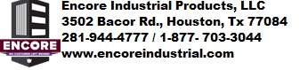

SUPERIOR INSULATING FILm

DANGER EXTREMELY FLAMMABLE LIQUID AND VAPOR. VAPORS MAY CASUE FLASH FIRE. CONTENTS UNDER PRESSURE. VAPOR HARMFUL.
See other cautions on side panel

NET WT. 16.0 OZ (454G) POIDS NEW 454 G PESO NET 454g

DIRECTIONS FOR USE:
1. Surface must be clean, dry, and
free of rust before painting. Protect surrounding areas from spray mist. For best results, use when can is between 50°F and 90°F (10°C and 32°C)
2. Shake can at least one minute after rattle is heard and occasionally during use.
3. Spray surface with steady, even strokes at a distance of 80 to 10 inches (20 to 25cm). Several light coats give a better finish than one heavy coat.
4. If clogging develops, turn spray head ¼ turn or remove and clean spray head slot. DO NOT stick pin or other object into can opening. With can and spray head pointed away from you, reinsert spray head with a gentle twisting motion.
5. To clear spray head for future use, turn can upside down and spray for 3 seconds. Completely empty cans may be recycled or disposed with regular trash. Dispose partially empty cans responsibly. DO NOT incinerate or compact.
Contains: Acetone 67-64-1, Propane 74-98-6, Red Iron Oxide Pigment 1309-31-1, N-Butane 106-97-8, Toluene 108-88-3,N-Butyl Acetate 123-86-4, Glycol Ether EP 2807-30-9, Isopropyl Alcohol 67-63-0, Xylene 1330-20-7

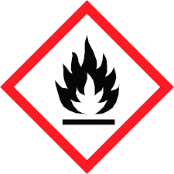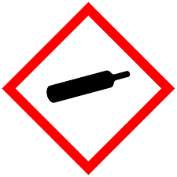

HMIS RATING:
Health
Flammability
Reactivity
Personal Protection

Made in the U.S.A.
FOR PROFESSIONAL USE ONLY

Storage Temperature 40-100°F
For cleanup use Encore Industrial’s FLUSH MONKEY or an equivalent solvent
Keep out of reach of children. Read Safety Data Sheet before use.

