HIGH GEAR 80W-90
INDUSTRIAL GEAR LUBRICANT

Ideal for industrial applications. Provides trouble free performance in high pressure high output industrial configurations. Helps eliminate sludge build up caused by heat. Designed to separate from water quickly to safeguard against etching acids or corrosives.

P.I.N. G-240-5GLP

Health | 1
Flammability | 1
Reactivity | 0
Personal | B

Batch Number: #

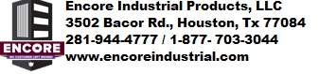

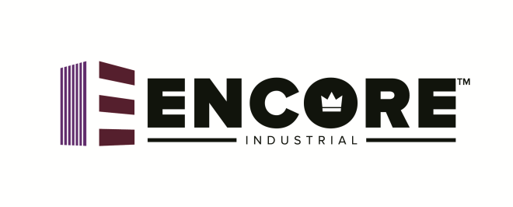
High Gear
80W-90
Oxidation Stabilizers
Extend Service Life
Inhibits Rust & Corrosion
Enhanced with Anti-Wear Additives
Meets GL-5 API Service Specs
Resists Deposit Formation
Protects Seals from Premature Wear

Keep Out Of Reach of Children
Net Contents
□ 5 Gallons □ 20 Gallons
□ 30 Gallons □ 55 Gallons

First Aid
Inhalation: Vapors generated at high temperatures (only) or oil mist may cause mild irritation of the nose, throat and respiratory system. Consult physician and poison control immediately.
Eye Irritation: May cause minimum eye irritation. Consult physician and poison control immediately.
Skin Contact: May cause minimum skin irritations, long term heavy exposure may dry or defat the skin. May also cause dermatitis or oil acne. High pressure injection under the skin could cause extensive tissue damage. Consult physician and poison control immediately.
Ingestion: If swallowed may be slightly toxic. Consult physician and poison control immediately.

Dispose of in accordance with local, state and federal regulations.

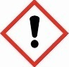
Warning: Harmful if inhaled. Avoid breathing dust/fumes/gas/mist/spray. Use only outdoors or in a well-ventilated area.

