Distributed Exclusively by
For Further Information Call
1-877-703-3044
281-944-4777
www.encoreindustrial.com

SAFETY DATA SHEET
APRIL 2018 PAGE 1 OF 5 eN 1215

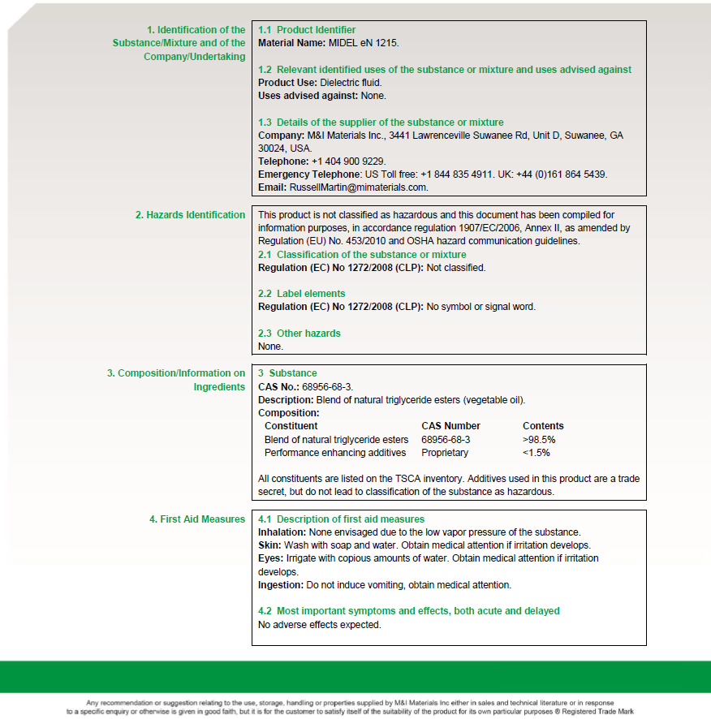
Distributed Exclusively by
For Further Information Call
1-877-703-3044
281-944-4777
www.encoreindustrial.com

SAFETY DATA SHEET
APRIL 2018 PAGE 2 OF 5 eN 1215

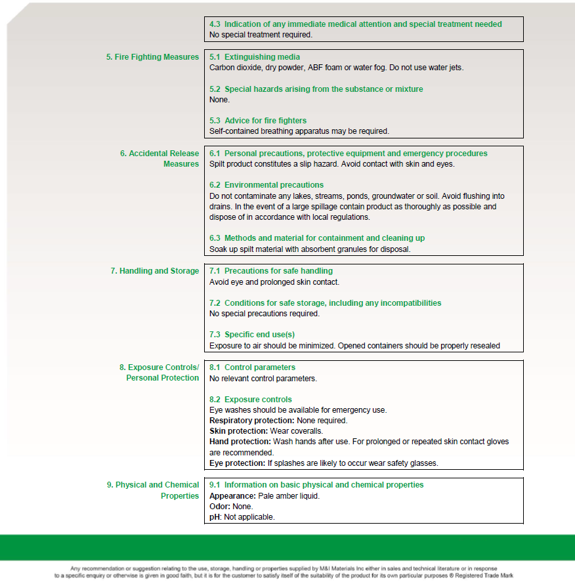
Distributed Exclusively by
For Further Information Call
1-877-703-3044
281-944-4777
www.encoreindustrial.com

SAFETY DATA SHEET
APRIL 2018 PAGE 3 OF 5 eN 1215

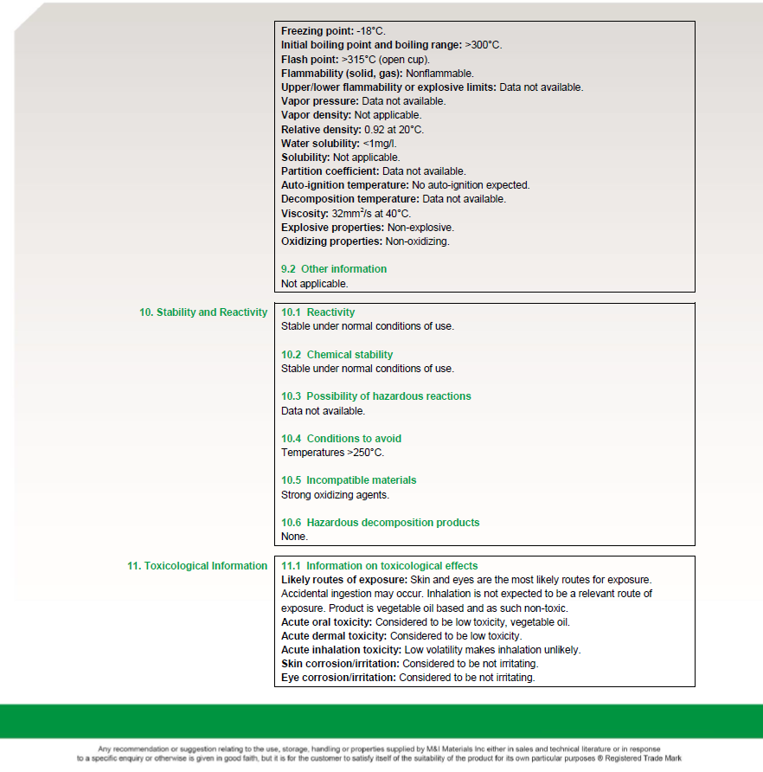
Distributed Exclusively by
For Further Information Call
1-877-703-3044
281-944-4777
www.encoreindustrial.com

SAFETY DATA SHEET
APRIL 2018 PAGE 4 OF 5 eN 1215
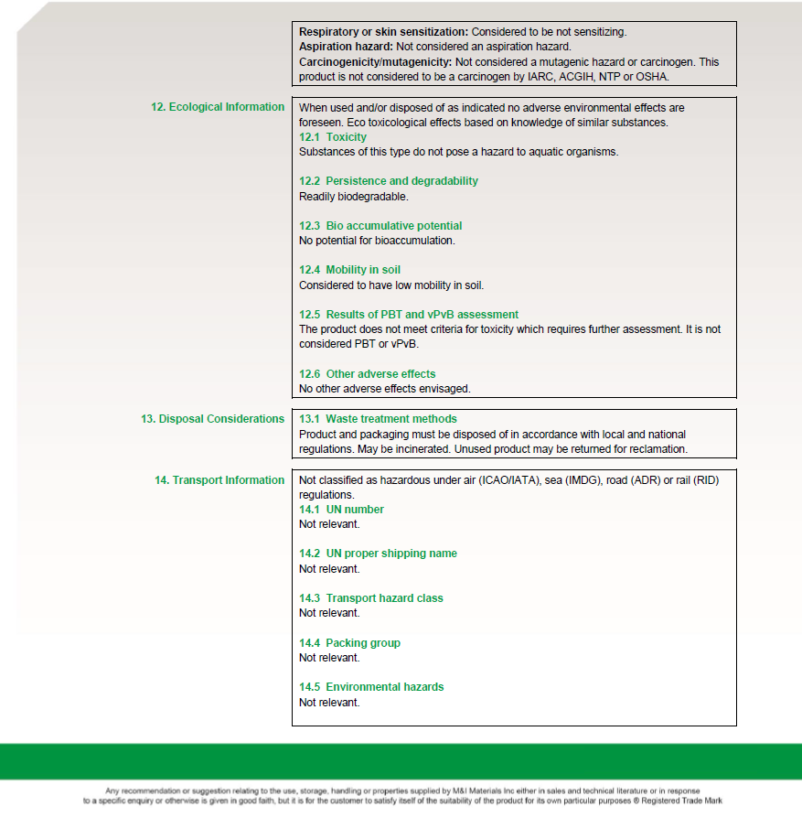
Distributed Exclusively by
For Further Information Call
1-877-703-3044
281-944-4777
www.encoreindustrial.com

SAFETY DATA SHEET
APRIL 2018 PAGE 5 OF 5 eN 1215

