SECTION 1 – PRODUCT AND COMPANY IDENTIFICATION

Product Name Pest Hunter VS - Deodorized Roach & Ant Insecticide

Updated Date February 10, 2016

Company Encore Industrial Products Transportation Emergency (24 Hour) Contact
P.O. Box 300 North America: 1-877-703-3044 Ex. 405
Barker, TX 77413-0300
Phone Number (281) 944-4777
(877) 703-3044
Fax (281) 944-4778 Medical Emergencies:
Contact your local Poison Control Center.

Transportation
DOT: CONSUMER COMMODITY, ORM-D
IATA: CONSUMER COMMODITY, ORM-D
IMDG: CONSUMER COMMODITY, ORM-D

SECTION 2 – HAZARDS IDENTIFICATION
Emergency Overview
May be irritating to sensitive skin

Hazard Classification: Aerosol Class 2 Signal Word(s): Warning/Irritant
Hazard Symbol(s): 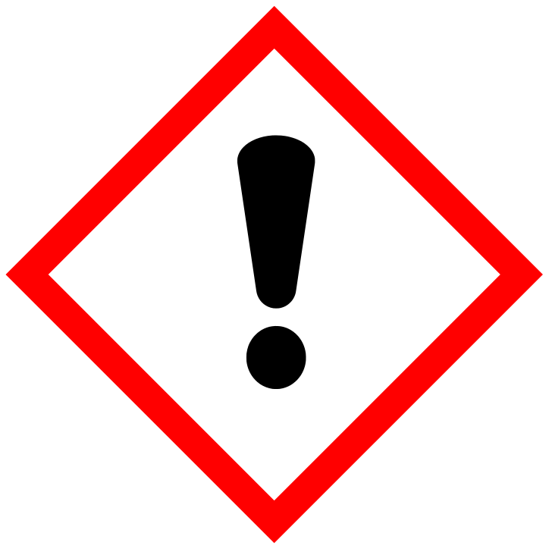
Hazard Statement: Aerosol can may burst if heated.
Precautionary Statements:
- FLAMMABLE. Keep away from fire or flame.
- Do not use in eyes. In case of eye contact, flush thoroughly with water and seek medical attention.
- Stop use and ask doctor if irritation and redness develop and persists for more than 72 hours.
- Keep out of reach of children. If swallowed, get medical help or contact a Poison Control Center right away.

SECTION 3 – COMPOSITION / INFORMATION ON INGREDIENTS
Ingredients considered hazardous as defined by OSHA, 29 CFR 1910.1200, WHMIS under the HPA (Canada),
or ESIS (Europe).

Chemical Name CAS Number % OSHA PEL ACGIH TLV
Tetramethrin 7696-12-0 .10 N/E N/E
Permethrin 52645-53-1 .25 N/E N/E
Piperonyl Butoxide 51-03-6 .50 N/E N/E
Petroleum Distillates 64742-47-8 >90.0 N/E N/E
Carbon Dioxide 124-38-9 1.00-10.0 10,000ppm 5000ppm

Remaining ingredients are non-hazardous and/or present at amounts below reportable limits and considered confidential.
SECTION 4 – FIRST AID MEASURES

Eye Contact Immediately flush the eye(s) with water for at least 15 minutes while holding eyelids open.
Seek medical attention in the event of an adverse reaction or if symptoms of irritation worsen.
Skin Contact In case of irritation, immediately wash affected area with soap and water. Seek medical
attention in the event of an adverse reaction or if symptoms of irritation worsen. Remove contaminated clothing and launder before reuse.
Ingestion Do not induce vomiting! Seek medical attention immediately. Note: Never give anything by mouth to an unconscious or convulsing victim. Keep person warm and quiet.
Inhalation If respiratory irritation or distress occurs, remove victim to fresh air and seek medical attention.
SECTION 5 – FIRE FIGHTING MEASURES

Flash Point & Method 177F Flammability Class Aerosol Class 2

Flammability Limits (% by vol) Lower Upper
N/A N/A

Extinguishing Media Use water fog, dry chemical or carbon dioxide
Unusual Fire & Explosion Hazards Aerosol can may rupture when heated.
Fire Fighting Instructions Use self-contained breathing apparatus and full protective gear if large quantities of product are involved. Heated cans my burst.

SECTION 6 – ACCIDENTAL RELEASE MEASURES

Personal Precautions Wear appropriate protective equipment (see Section 8).
Containment/Cleanup Safely stop source of spill. Dike or contain spill. Absorb with appropriate absorbent.
Clean area of spill and absorbent material. Dispose of all washings, sweepings, and
absorbents in accordance with all applicable federal, state, and local regulations.
Spills may be reportable to the National Response Center (800-424-8802).

SECTION 7 – HANDLING AND STORAGE

Handling When spraying more than one half can continuously or more than one can consecutively, use NIOSH approved respirator.
Storage Store at temperatures below 120ºF. Keep away from children. For use by trained personnel only. Keep away from heat, sparks, or open flame. For industrial and institutional use only. Keep container closed during storage.

SECTION 8 – EXPOSURE CONTROLS / PERSONAL PROTECTION

Control Parameters Industrial Setting: Refer to Section 3 for ingredients with occupational exposure limits.
Engineering Controls This is a consumer product that is safe for consumers under normal and reasonably
foreseeable use. For industrial settings, use in well ventilated area.
Personal Protective Respiratory protection: Self-contained breathing apparatus if above TLV limit.
Equipment Eye/Face: Safety glasses or goggles if splash hazards exist.
Skin: Gloves; rubber, neoprene, or other impervious material for excessive or prolonged contact.
Work Hygienic Practices Always follow good hygienic work practices.

SECTION 9 – PHYSICAL AND CHEMICAL PROPERTIES

Color and Appearance Clear liquid VOC Content Not Known
Odor Vanilla Scent Boiling Point <0 to 390ºF
pH Not Known Melting Point Greater than 120ºF
Specific Gravity Not Known Vapor Density >1
Flash Point N/A Solubility in Water Insoluble

SECTION 10 – STABILITY AND REACTIVITY

Chemical Stability Stable
Conditions to Avoid Heat and open flame; Dropping of containers may cause bursting.
Incompatible Materials Oxidizers, acids and bases;
Hazardous Decomposition In fire will decompose to carbon dioxide, carbon monoxide.
Products
Hazardous Polymerization Will not occur.

SECTION 11 – TOXICOLOGICAL INFORMATION

Toxicity Tests Data is not available.
Potential Health Effects Acute Eye: Eye irritant. Will cause redness and burning sensation.
Acute Skin: Skin irritant. Will cause defatting of skin. Effects are reversible.
Acute Inhalation: Effects of overexposure include irritation of respiratory tract, headache, dizziness, nausea, and loss of coordination. Extreme overexposure may result in unconsciousness and possibly death.
Acute Ingestion: Aspiration hazard if swallowed.
Chronic Effects: Not expected to have chronic health effects.
Carcinogenicity: Not expected to be carcinogenic.

SECTION 12 – ECOLOGICAL INFORMATION

Ecological Tests: Data is not available.
Environmental Impact: The product ingredients are expected to be safe for the environment at concentrations predicted under normal use and accidental spill scenarios. Packaging components are compatible with the conventional solid waste management practices.

SECTION 13 – DISPOSAL CONSIDERATIONS

Disposal Methods Dispose of according to local, state, and federal regulations.

SECTION 14 – TRANSPORT INFORMATION

Identification Proper Hazardous Packaging
Shipment Number Shipping Name Classification Group
US DOT None CONSUMER COMMODITY ORM-D None
IATA (air) None CONSUMER COMMODITY ORM-D None
IMDG (vessel) None CONSUMER COMMODITY ORM-D None

SECTION 15 – REGULATORY INFORMATION

USA FDA This product is regulated as an Over-The-Counter (OTC) drug under the Federal Food, Drug,
and Cosmetics Act and complies with FDA regulations.
EPA SARA Title III Sections 302/304, 311/312, and 313 chemical listings: None or none present
In regulated quantities.
CAA Section 112 listings (TQ): None
CERLCA Reportable Quantity (RQ): None.

California Proposition 65: This product is not subject to warning labeling.
State Right-To-Know The following ingredients are present in the finished product and
are listed on the following state right-to-know lists:
Ingredient CAS No. Percent State
No reportable ingredients
Canada This product is regulated as a Natural Health Product (NHP) under the Food and Drugs Act and complies
with Health Canada regulations. All chemical components of this product are listed on DSL, NDSL, ICL
or exempt.

Europe EU Classification: Aerosol Class 2.
EU Risk Phrases: R10 – Flammable.
EU Safety Phrases: S2 – Keep out of reach of children. S46 – If swallowed, seek medical advice
immediately and show this container or label. S56 – Dispose of this material
and its container to hazardous or special waste collection point.

SECTION 16 – OTHER INFORMATION

Legend
ACGIH American Conference of Governmental ICL In-Commerce List (Canada)
Industrial Hygienists IMO International Maritime Organization
CAA Clean Air Act N/A Not Applicable
CAS Chemical Abstract Service NDSL Non-Domestic Substances List (Canada)
CERCLA CERCLA Hazardous Substances N/E Not Established
CFR Code of Federal Regulations NTP National Toxicology Program
DOT Department of Transportation OSHA Occupational Safety & Health Administration
DSL Domestic Substances List (Canada) PEL Permissible Exposure Limits
EINECS European Inventory of Existing RCRA Resource Conservation and Recovery Act
Chemical Substances SARA Superfund Amendments and Reauthorizations Act
EPA Environmental Protection Agency TLV Threshold Limit Values
FDA Food and Drug Administration TQ Threshold Quantities
HPA Hazardous Products Act (Canada) TWA Time Weighted Average
IARC International Agency for Research on Cancer VOC Volatile Organic Compounds
IATA International Air Transport Association WHMIS Workplace Hazardous Materials Information System

This document is intended to provide a brief summary of our knowledge and guidance regarding the use of this material. The information set forth herein has been compiled from sources considered to be dependable and is believed to be accurate as of the date of publication. This information is offered in good faith by Encore Industrial and no warranty, expressed or implied is made. The user assumes all liability for any damage or injury resulting from misuse, from any failure to adhere to recommended practices or from any hazards inherent in the nature of the product.

