SECTION 1 – PRODUCT AND COMPANY IDENTIFICATION

Product Name Skip – Special Kill Insecticide Powder

Effective Date February 26, 2016

Company Encore Industrial Products Transportation Emergency (24 Hour) Contact
P.O. Box 300 North America: 1-877-703-3044 Ex. 405
Barker, TX 77413-0300
Phone Number (281) 944-4777
(877) 703-3044
Fax (281) 944-4778 Medical Emergencies:
Contact your local Poison Control Center.

Transportation
DOT: Not Regulated
IATA: Not Regulated
IMDG: Not Regulated

SECTION 2 – HAZARDS IDENTIFICATION
Emergency Overview
Harmful to skin and eyes; Do not ingest.

Hazard Classification: None Signal Word(s): None
Hazard Symbol(s): None
Hazard Statement: Not applicable
Precautionary Statements:
- Do not use in eyes. In case of eye contact, flush thoroughly with water and seek medical attention.
- Stop use and ask doctor if irritation and redness develop and persists for more than 72 hours.
- Keep out of reach of children. If swallowed, get medical help or contact a Poison Control Center right away.

SECTION 3 – COMPOSITION / INFORMATION ON INGREDIENTS
Ingredients considered hazardous as defined by OSHA, 29 CFR 1910.1200, WHMIS under the HPA (Canada),
or ESIS (Europe).

Chemical Name CAS Number % AGGIH/TWA
Hydrocarbons, C11-C14, n-alkanes,
Isoalkanes, cyclics, <2% aromatics 64742-47-8 1.0 – 5.0
Pyrethrins including cinerins, with the
Exception of those specified else where 8003-34-7 0.5 – 1.5 5 mg/m3

Remaining ingredients are non-hazardous and/or present at amounts below reportable limits and considered confidential.

SECTION 4 – FIRST AID MEASURES

Eye Contact Immediately flush the eye(s) with water for at least 15 minutes while holding eyelids open.
Seek medical attention in the event of an adverse reaction or if symptoms of irritation worsen.
Skin Contact In case of irritation, immediately wash affected area with soap and water. Seek medical
attention in the event of an adverse reaction or if symptoms of irritation worsen. Remove contaminated clothing and launder before reuse.
Ingestion Do not induce vomiting! Rinse mouth out with water. Seek medical attention immediately. Note: Never give anything by mouth to an unconscious or convulsing victim. Keep person warm and quiet.
Inhalation If respiratory irritation or distress occurs, remove victim to fresh air and seek medical attention.
SECTION 5 – FIRE FIGHTING MEASURES

Flash Point & Method N/A Flammability Class Aerosol Class 2

Flammability Limits (% by vol) Lower Upper
N/A N/A

Extinguishing Media Use water spray, dry chemical or carbon dioxide
Unusual Fire & Explosion Hazards Upon combustion: CO and CO2 are formed.
Fire Fighting Instructions Exercise caution when fighting any chemical fire; Use water spray or fog for cooling off containers; Take account of environmentally hazardous firefighting water; Wear protective gear.

SECTION 6 – ACCIDENTAL RELEASE MEASURES

Personal Precautions Isolate from fire, if possible, without unnecessary risk; Protective googles, gloves and protective clothing; Evacuate unnecessary personnel;
Containment/Cleanup Avoid release to the environment; Prevent entry to sewers and public waters; Collet spillage and dispose of in a safe way as per local legislation,

SECTION 7 – HANDLING AND STORAGE
Handling Comply with legal requirements; Do not handle until all safety precautions have been read and understood. Use personal protective equipment as required. Do not eat, drink, or smoke when using this product; Do not get in eyes, on skin, or on clothing.
Storage Coly with applicable regulations; keep container closed when not in use; Oxidizing agent; Meet the legal requirements; Store in cool dry well ventilated area;
SECTION 8 – EXPOSURE CONTROLS / PERSONAL PROTECTION

Control Parameters Industrial Setting: Refer to Section 3 for ingredients with occupational exposure limits.
Engineering Controls This is a consumer product that is safe for consumers under normal and reasonably
foreseeable use. For industrial settings, use in well ventilated area.
Personal Protective Respiratory protection: Self-contained breathing apparatus if above TLV limit.
Equipment Eye/Face: Safety glasses or goggles if splash hazards exist.
Skin: Gloves; rubber, neoprene, or other impervious material for excessive or prolonged contact.
Work Hygienic Practices Always follow good hygienic work practices.

SECTION 9 – PHYSICAL AND CHEMICAL PROPERTIES

Color and Appearance Fine white powder VOC Content Not Known
Odor Mild Boiling Point No data available
pH 6.6 @ 20% (v/v) washed in water Melting Point No Data Available
Specific Gravity 0.304 g/cm3 Vapor Density >1
Flash Point >200F TAG Closed Cup Solubility in Water No data Available

SECTION 10 – STABILITY AND REACTIVITY

Chemical Stability No additional information available;
Conditions to Avoid No additional information available;
Incompatible Materials No additional information available;
Hazardous Decomposition In fire will decompose to carbon dioxide, carbon monoxide.
Products
Hazardous Polymerization No additional information available;

SECTION 11 – TOXICOLOGICAL INFORMATION

Toxicity Tests
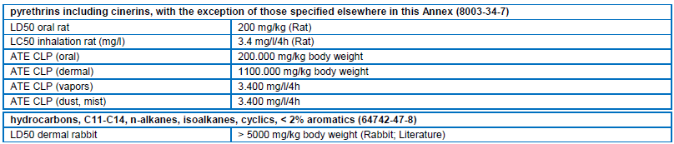
Potential Health Effects Acute Eye: Direct contact with the eyes is likely to cause irritation
Acute Skin: Harmful in contact with skin
Acute Inhalation: May cause respiratory irritation
Acute Ingestion: Gastrointestinal complaints
Chronic Effects: Not expected to have chronic health effects.
Carcinogenicity: Not expected to be carcinogenic.

SECTION 12 – ECOLOGICAL INFORMATION

Ecological Tests:
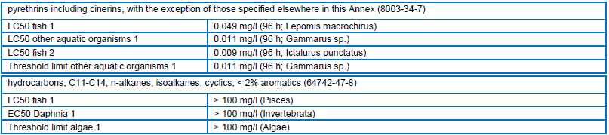
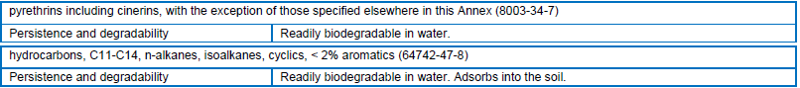
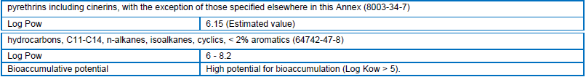

SECTION 13 – DISPOSAL CONSIDERATIONS

Disposal Methods Dispose of according to local, state, and federal regulations.

SECTION 14 – TRANSPORT INFORMATION

Identification Proper Hazardous Packaging
Shipment Number Shipping Name Classification Group
US DOT None Not regulated None None
IATA (air) None Not regulated None None
IMDG (vessel) None Not regulated None None

SECTION 15 – REGULATORY INFORMATION

USA FDA This product is regulated as an Over-The-Counter (OTC) drug under the Federal Food, Drug,
and Cosmetics Act and complies with FDA regulations.
EPA SARA Title III Sections 302/304, 311/312, and 313 chemical listings: None or none present
In regulated quantities.
CAA Section 112 listings (TQ): None
CERLCA Reportable Quantity (RQ): None.

California Proposition 65: This product is not subject to warning labeling.
State Right-To-Know The following ingredients are present in the finished product and
are listed on the following state right-to-know lists:
Ingredient CAS No. Percent State
No reportable ingredients
Canada This product is regulated as a Natural Health Product (NHP) under the Food and Drugs Act and complies
with Health Canada regulations. All chemical components of this product are listed on DSL, NDSL, ICL
or exempt.

Europe EU Classification: Aerosol Class 2.
EU Risk Phrases: R10 – Flammable.
EU Safety Phrases: S2 – Keep out of reach of children. S46 – If swallowed, seek medical advice
immediately and show this container or label. S56 – Dispose of this material
and its container to hazardous or special waste collection point.

SECTION 16 – OTHER INFORMATION

Legend
ACGIH American Conference of Governmental ICL In-Commerce List (Canada)
Industrial Hygienists IMO International Maritime Organization
CAA Clean Air Act N/A Not Applicable
CAS Chemical Abstract Service NDSL Non-Domestic Substances List (Canada)
CERCLA CERCLA Hazardous Substances N/E Not Established
CFR Code of Federal Regulations NTP National Toxicology Program
DOT Department of Transportation OSHA Occupational Safety & Health Administration
DSL Domestic Substances List (Canada) PEL Permissible Exposure Limits
EINECS European Inventory of Existing RCRA Resource Conservation and Recovery Act
Chemical Substances SARA Superfund Amendments and Reauthorizations Act
EPA Environmental Protection Agency TLV Threshold Limit Values
FDA Food and Drug Administration TQ Threshold Quantities
HPA Hazardous Products Act (Canada) TWA Time Weighted Average
IARC International Agency for Research on Cancer VOC Volatile Organic Compounds
IATA International Air Transport Association WHMIS Workplace Hazardous Materials Information System

This document is intended to provide a brief summary of our knowledge and guidance regarding the use of this material. The information set forth herein has been compiled from sources considered to be dependable and is believed to be accurate as of the date of publication. This information is offered in good faith by Encore Industrial and no warranty, expressed or implied is made. The user assumes all liability for any damage or injury resulting from misuse, from any failure to adhere to recommended practices or from any hazards inherent in the nature of the product.

