SECTION 1 – PRODUCT AND COMPANY IDENTIFICATION

Product Name D-Limonext - Bio Engineered Degreaser and Organic Solvent

Updated Date January 17, 2020
Supersedes Date: June 1, 2016

Company Encore Industrial Products Transportation Emergency (24 Hour) Contact
P.O. Box 300 North America: 1-877-703-3044 Ex. 405
Barker, TX 77413-0300 CHEM TEL 800-255-3924
Phone Number (281) 944-4777
(877) 703-3044
Fax (281) 944-4778 Medical Emergencies:
Contact your local Poison Control Center.

Transportation
DOT: CONSUMER COMMODITY, ORM-D
IATA: CONSUMER COMMODITY, ORMD-D
IMDG: COMSUMER COMMODITY, ORM-D

SECTION 2 – HAZARDS IDENTIFICATION
2.1 Classification of the substance or mixture

GHS-US classification
Flam. Liq. 4 Combustible liquid
Skin Irrit. 2 Causes skin irritation
Skin Sens. 1 May cause an allergic skin reaction
Flam. Liq. 3 Flammable liquid and vapor

2.2 Label Elements
Hazard Classification: Flammable Signal Word(s): Warning

Hazard Symbol(s): 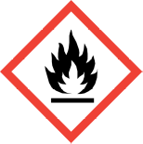

Hazard Statements (GHS-US):
Combustible liquid
Causes skin irritation
May cause an allergic skin reaction

Precautionary statements (GHS-US) :
Keep away from heat, sparks, open flames, No smoking. - No smoking
Avoid breathing mist, spray, and vapors
Wash hands thoroughly after handling
Contaminated work clothing must not be allowed out of the workplace
Wear protective gloves, eye protection, face protection
(Continued on next page)

If on skin: Wash with plenty of Wash off with soap and plenty of water
Specific treatment (See first aid section of this material safety data sheet on this label)

If skin irritation occurs: Get medical advice/attention

If skin irritation or rash occurs: Get medical advice/attention
Take off contaminated clothing and wash it before reuse
Wash contaminated clothing before reuse

In case of fire: Use Suitable extinguishing media to extinguish
Store in a well-ventilated place. Keep cool
Dispose of contents/container to an approved waste disposal plant

SECTION 3 – COMPOSITION / INFORMATION ON INGREDIENTS

Ingredients considered hazardous as defined by OSHA, 29 CFR 1910.1200, WHMIS under the HPA (Canada),
or ESIS (Europe).

Chemical Name CAS Number Other Limits Wt % OSHA PEL ACGIH TLV GHS-US Class.
D-Limonene 5989-27-5 4400 mg/kg 80-100 NE NE Flam. Liq. 3, H226
Skin Irrit. 2, H315
Skin Sens. 1, H317
Aquatic Acute 1, H400
Aquatic Chronic 1, H410

(RAT/ORAL)
Remaining ingredients are non-hazardous and/or present at amounts below reportable limits and considered confidential.

SECTION 4 – FIRST AID MEASURES

Eye Contact Rinse immediately with plenty of water. Obtain medical attention if pain, blinking or redness persist
Skin Contact Rinse skin with water/shower. Wash with plenty of soap and water. Wash contaminated clothing before reuse. If skin irritation occurs: Gently wash with plenty of soap and water, Get medical advice/attention. Specific treatment (see first aid section on this label.)
Ingestion Rinse mouth. Do NOT induce vomiting. Obtain emergency medical attention.
Inhalation Allow breathing of fresh air. Allow the victim to rest

SECTION 5 – FIRE FIGHTING MEASURES

Flash Point & Method 115ºF - 125ºF Flammability Class: Class 2 liquids

Flammability Limits (% by vol) Lower Upper
0.7 16.1

Extinguishing Media Dry chemical; Foam; Carbon dioxide (Do not use water except as a mist or foam, as it may spread the burning.)
Unusual Fire & Explosion Hazards Rags soaked with this product may spontaneously ignite; to avoid the
Danger, used rags should be soaked with water and/or stored in a container
full of soapy water. In a fire, closed containers of the product my burst
or rupture due to pressure build-up, greatly increasing the fire hazard.
Fire Fighting Instructions Wear self-contained breathing apparatus with full protective clothing.
Containers should be cooled with water to prevent vapor pressure build up.

SECTION 6 – ACCIDENTAL RELEASE MEASURES

Personal Precautions Wear appropriate protective equipment (see Section 8).
Containment/Cleanup Small spills: Soak up with an inert absorbent and place in designated disposal container. Rinse area thoroughly.
Large spills: Remove sources of ignition and ventilate area. Soak up with an inert absorbent and place in designated disposal container. Rinse area thoroughly.

SECTION 7 – HANDLING AND STORAGE

Handling Utilize standard safe handling and transportation techniques to avoid spillage or rupture of the product;
Avoid eye contact. Do not smoke while using this product. Do not take internally.
Storage Do not store at temperatures extreme. Keep containers tightly closed when not in use. Store in a cool, dry, well-ventilated area away from sources of ignition. Do not take internally.

SECTION 8 – EXPOSURE CONTROLS / PERSONAL PROTECTION

Control Parameters Industrial Setting: Refer to Section 3 for ingredients with occupational exposure limits.
Engineering Controls For industrial settings, use in well ventilated area.
Personal Protective Respiratory protection: Not required if in a well ventilated area.
Equipment Eye/Face: Safety glasses or goggles.
Skin: Chemical resistant gloves. Long sleeves and pants.
Work Hygienic Practices Always follow good hygienic work practices.

SECTION 9 – PHYSICAL AND CHEMICAL PROPERTIES

Color and Appearance Clear, thin orange liquid VOC Content 100%
Odor Citrus Boiling Point 310
pH N/D Melting Point N/D
Specific Gravity 0.85 Vapor Density 4.9
Flash Point 145 Solubility in Water Dispersible, forms emulsion

SECTION 10 – STABILITY AND REACTIVITY

Chemical Stability: Flammable liquid and vapor. May form flammable/explosive vapor-air mixture.
Conditions to Avoid: Direct Sunlight. Extremely high or low temperatures. Open Flames. Overheating. Heat. Sparks.
Incompatible Materials: Oxidizing agents such as bleach; Strong acids. Strong Bases.
Hazardous Decomposition Carbon monoxide. Carbon Dioxide. May release flammable gases.
Products
Hazardous Polymerization N/A

SECTION 11 – TOXICOLOGICAL INFORMATION
12.1Toxicity
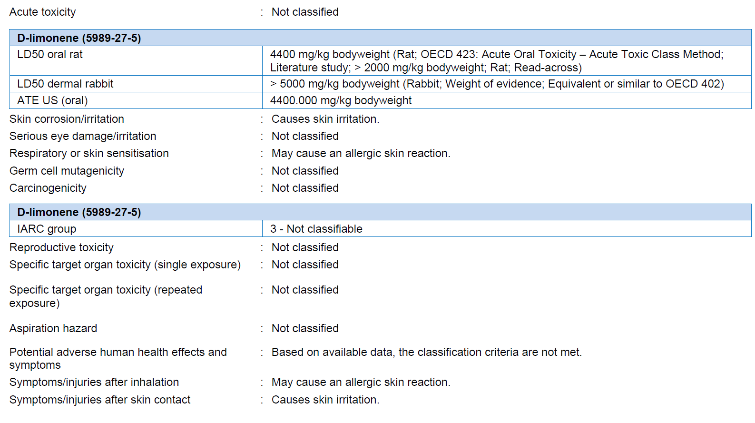
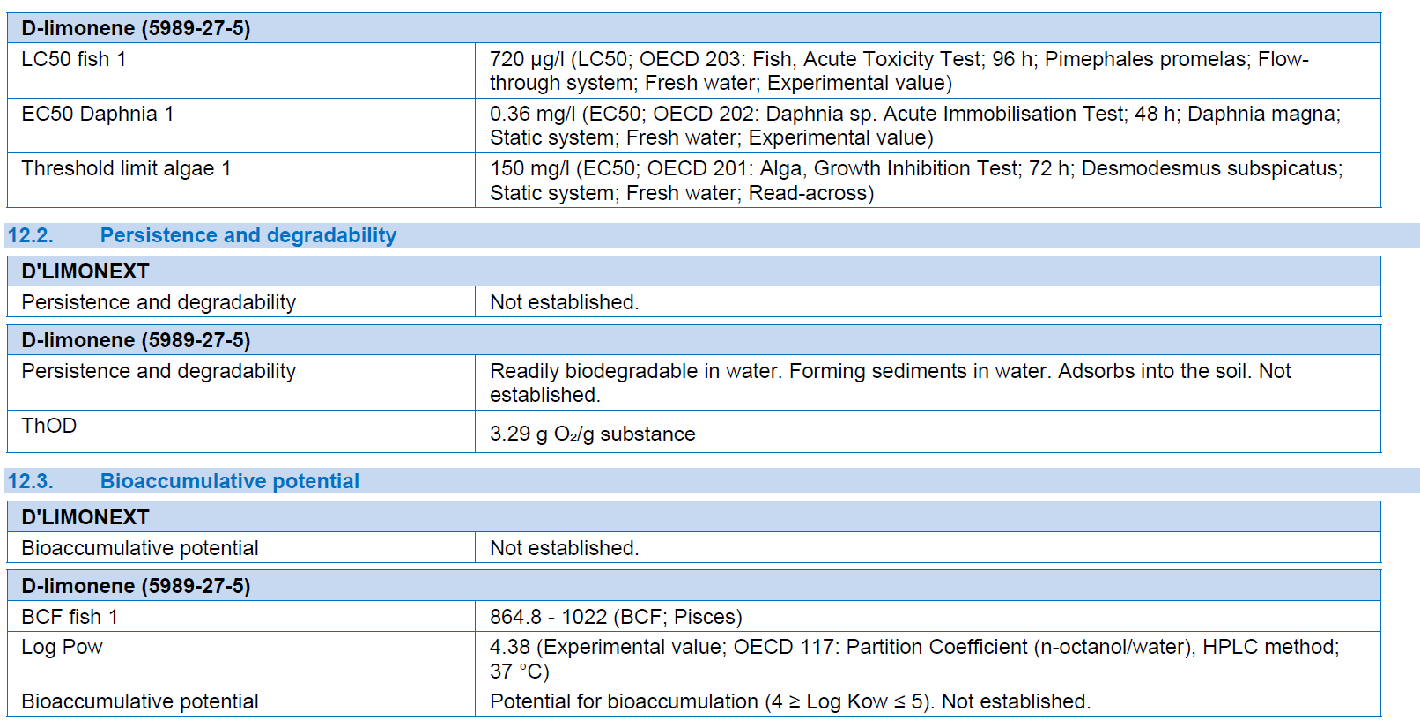
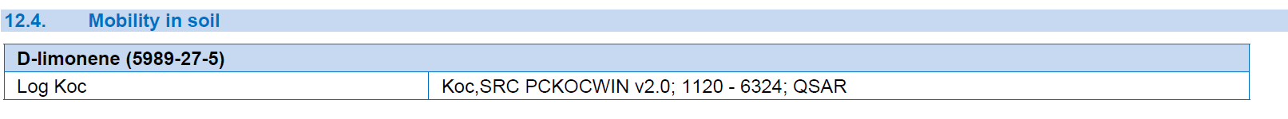
SECTION 12 – ECOLOGICAL INFORMATION

Ecological Tests: Data is not available.
Environmental Impact: The product ingredients are expected to be safe for the environment at concentrations predicted under normal use and accidental spill scenarios. Packaging components are compatible with the conventional solid waste management practices.

SECTION 13 – DISPOSAL CONSIDERATIONS

Disposal Methods Unused product is RCRA ignitable hazardous waste (D001). Dispose of according to local,
state, and federal regulations. Handle empty containers with care because residual vapors are flammable. Avoid releasing
into the environment.

SECTION 14 – TRANSPORT INFORMATION

Identification Proper Hazardous Packaging
Shipment Number Shipping Name Classification Group
US DOT N/A Not Regulated N/A N/A
IATA (air) N/A Terpene Hydrocarbons, n.o.s N/A N/A
IMDG (vessel) N/A Terpene Hydrocarbons, n.o.s N/A N/A

SECTION 15 – REGULATORY INFORMATION

USA All components of this product are listed, or excluded from listing, on the United States Environmental Protection Agency Toxic Substances Control Act (TSCA) inventory

This product or mixture does not contain a toxic chemical or chemicals in excess of the applicable de minimis concentration as specified in 40 CFR §372.38(a) subject to the reporting requirements of section 313 of Title III of the Superfund Amendments and Reauthorization Act of 1986 and 40 CFR Part 372.

California Proposition 65: This product is not subject to warning labeling.
State Right-To-Know The following ingredients are present in the finished product and
are listed on the following state right-to-know lists:
Ingredient CAS No. Percent State
N/A N/A N/A N/A
Canada This product is regulated as a Natural Health Product (NHP) under the Food and Drugs Act and complies
with Health Canada regulations. All chemical components of this product are listed on DSL, NDSL, ICL
or exempt.

SECTION 16 – OTHER INFORMATION

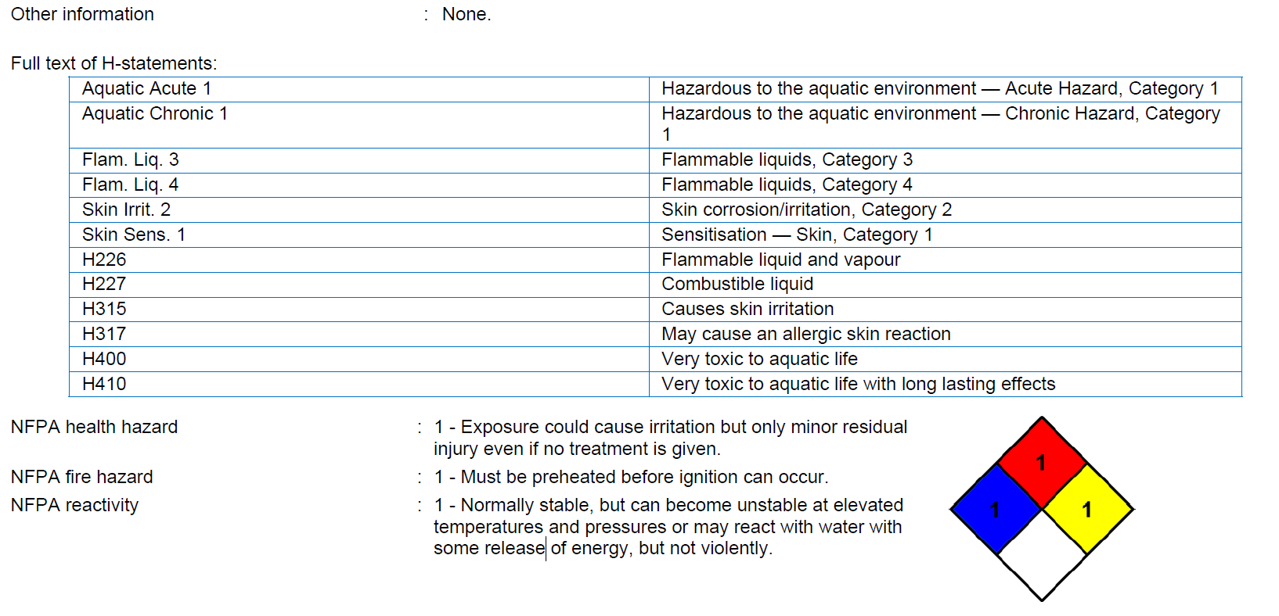
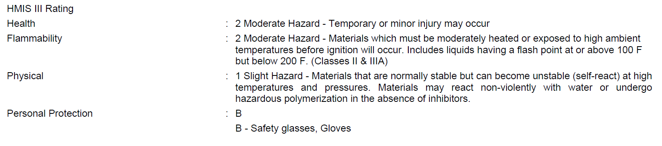

Legend
ACGIH American Conference of Governmental ICL In-Commerce List (Canada)
Industrial Hygienists IMO International Maritime Organization
CAA Clean Air Act N/A Not Applicable
CAS Chemical Abstract Service NDSL Non-Domestic Substances List (Canada)
CERCLA CERCLA Hazardous Substances N/E Not Established
CFR Code of Federal Regulations NTP National Toxicology Program
DOT Department of Transportation OSHA Occupational Safety & Health Administration
DSL Domestic Substances List (Canada) PEL Permissible Exposure Limits
EINECS European Inventory of Existing RCRA Resource Conservation and Recovery Act
Chemical Substances SARA Superfund Amendments and Reauthorizations Act
EPA Environmental Protection Agency TLV Threshold Limit Values
FDA Food and Drug Administration TQ Threshold Quantities
HPA Hazardous Products Act (Canada) TWA Time Weighted Average
IARC International Agency for Research on Cancer VOC Volatile Organic Compounds
IATA International Air Transport Association WHMIS Workplace Hazardous Materials Information System

This document is intended to provide a brief summary of our knowledge and guidance regarding the use of this material. The information set forth herein has been compiled from sources considered to be dependable and is believed to be accurate as of the date of publication. This information is offered in good faith by Encore Industrial and no warranty, expressed or implied is made. The user assumes all liability for any damage or injury resulting from misuse, from any failure to adhere to recommended practices or from any hazards inherent in the nature of the product.

