VAP Catch utilizes the latest ultra-modern technology to suppress vapors and biologically clean surfaces and various substrates. This product utilizes Patented Bio-Enzymatic Technology to effectively reduce VOC’s and remediate several thousand different hydrocarbons in crude oil and refined products like gasoline, diesel, and lubricating oils.

Produces 4 Trillion Nonpathogenic
Bacterial count per gallon
VAP Catch degrades a wide variety of hydrocarbon compounds such as: Gas, Oil, and BTEX Compounds:
(benzyne, toluene, xylene), phenol, catechol, cresol, polyaromatics, naphthalene, phenanthrene, and biphenyl.

This highly concentrated formula can be used to help de-gas vessels for entry, remove and reduce buildup of sludge and petroleum as in separation tanks & sump pumps in industrial drain systems. Industrial sour odors are reduced along with the fumes.

P.I.N. I-225

Health | 1
Flammability | 0
Reactivity | 0
Personal | A
Batch Number: #

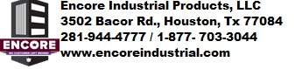
VAP
VAPOR ENCAPSULATING AGENT
& Biological cleaner
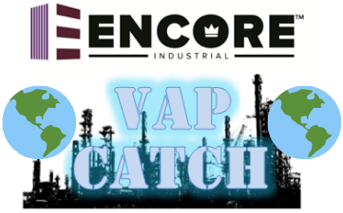
VAPOR ENCAPSULATING AGENT
& BIOLOGICAL CLEANER

Patented Bio-Enzymatic Technology
Proprietary Oil Microbe Consumption
Degrades Petroleum Hydrocarbons
Delivers Immediate Surface Cleaning
Penetrates Deep into the Subsurface
Nonhazardous●Nontoxic●Non-caustic
Non-acidic●Noncorrosive
100% Safe on All Equipment
Readily Biodegradable
VOC Reduction Formula
Ideal for Oil Spill Clean Up Remediation
Neutral pH for Safe Handling

Caution: Keep Out Of Reach of Children. See side panel for additional precautions & first aid.

Net Contents
□ 5 Gallons □ 20 Gallons
□ 30 Gallons □ 55 Gallons
□ 275 Tote

General Use
- Use as a vapor suppressant.
- Use as fuel spill remediation, product to consume deeply absorbed hydrocarbons through synthesized microbe consumption.
- Use to remove & reduce sludge and oil build up on industrial equipment: pumps, separators, and sumps in drains.
- Use to eliminate oil sheen and oil spills.
- Use to achieve superior hydrocarbon removal from metal & concrete surfaces.
- Use to de-gas vessel compartments.
- Use to remediate hydrocarbons on soil & water.
- Use to remove the industrial sour odor & fumes.
- Use around waterways where environmentally green products must be used.
- Use to reduce oil build up in separation tanks.

Dispose of in accordance with local, state and federal regulations.

Stoage and Handling
Store in closed container at room temperature.
First Aid
Never give anything by mouth to an unconscious person. If you feel unwell, seek medical advice (show the label where possible). If inhaled: Allow breathing of fresh air. Allow the victim to rest. If on skin: Remove all affected clothing and wash all exposed skin area with mild soap and water, followed by warm water rinse. If in eyes: Rinse immediately with plenty of water. Obtain medical attention if pain, blinking or redness persists. If ingested: Rinse mouth. Do NOT induce vomiting. Obtain emergency medical attention.

